**[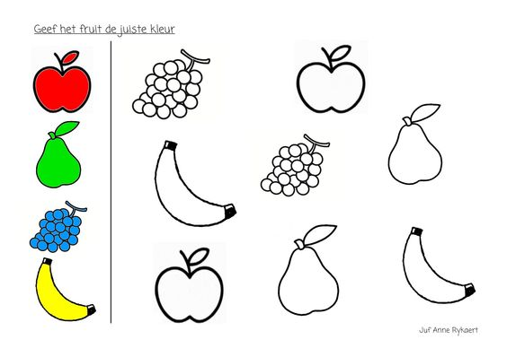](https://s-media-cache-ak0.pinimg.com/originals/e2/60/36/e26036cb4b773de6dcf8a0a70d6cb63a.jpg)**